**CCT College Dublin**

**Assessment Cover Page**

| **Module Title:** | Strategic Business Information Technology  Problem Solving for Industry (Capstone Project) |
| --- | --- |
| **Assessment Title:** | Group Project Strategic Analysis |
| **Lecturer Name:** | *Ken Healy Muhammad Iqbal*  *Dr. Muhammad Iqbal* |
| **Student Full Name:** | Eric Kim Mabe Pedro Henrique Marcal |
| **Student Number:** | 2020366 2020300 |
| **Assessment Due Date:** | Tuesday 20th February 2024 |
| **Date of Submission:** | Saturday 16th March 2024 at 23:59 |

**Declaration**

| By submitting this assessment, I confirm that I have read the CCT policy on Academic Misconduct and understand the implications of submitting work that is not my own or does not appropriately reference material taken from a third party or other source. I declare it to be my own work and that all material from third parties has been appropriately referenced. I further confirm that this work has not previously been submitted for assessment by myself or someone else in CCT College Dublin or any other higher education institution. |
| --- |

Table of Contents

Introduction

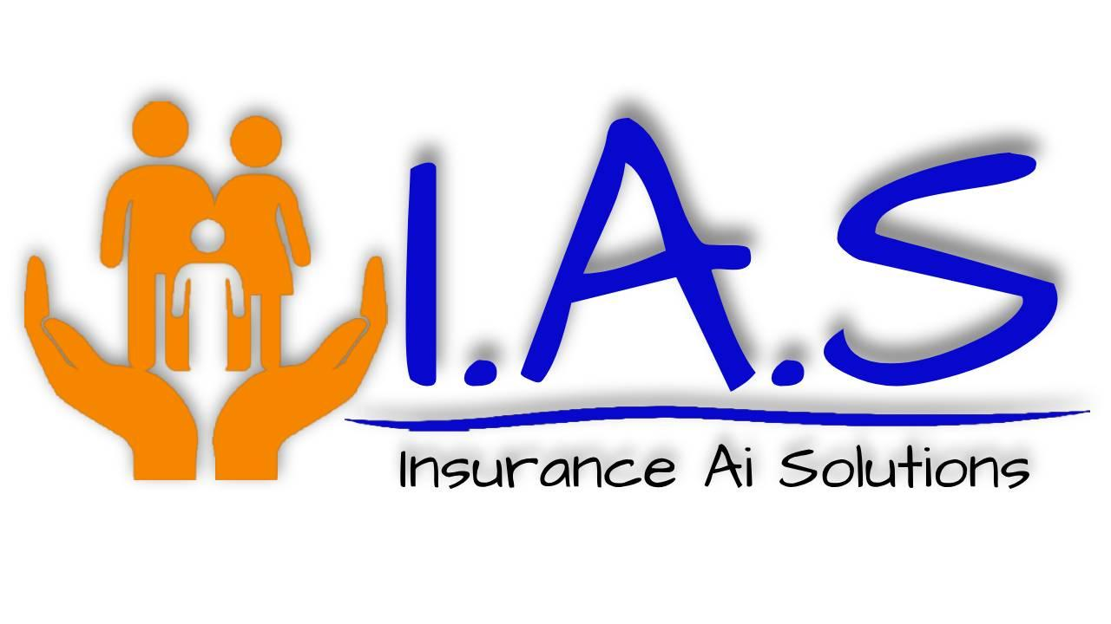

(Text ………………………………………………………………………………………………………..

…………………………………………………………………………………………………………

………………………………………………………………………………………………………….)

Report

Overview

Thinking about food habits and how we could incentivize healthy habits while making money from it using AI, we came up with an idea, create a software and feed it with data from food calories all over Europe and train it to identify potential risks within the zones and make a customised budget based on where that person lives. The presence of AI in the Insurance sector has been growing a lot, being used to support chatbots in the websites and. The AI developed by our company, AInsurance, aims to be a more accurate, precise, modern and fair way to help insurance companies to create personalised pricing for each customer. By analysing the food habits and dietary patterns within each zone, our software will see and analyse possible risk factors and define the insurance price accordingly, becoming less likely to human errors. To incentivize healthy food habits, we plan to give benefits or discounts to the zones where they show healthiest dietary habits.

Foods Habit per Zone and Its Significance

By analysing the dataset we have, we are able to see and manipulate the info needed to check the food habits of different zones over Europe. Within our data, we are able to create a software that will analyse possible risks that people can have over Europe and price them accordingly while profiting.

Potential Impacts in the Insurance Sector

b) Use a business analysis approach, or method, (either from those listed under the ‘Guidance’ section or another one you are familiar with) to make your case for why organisation(s) would want to use/buy your project (product or service) commercially. [Consider: How is it useful? What competitive advantage(s) might arise? Who might use it? Why would they pay money for it, and so on.]

SWOT Analysys

c) Provide a high-level overview of TWO of the technologies that you have selected and compare these with at least one possible alternative. Justify your technology selection(s) and explain why an Open-Source choice is better/more appropriate than a proprietary alternative (or, if you have chosen proprietary software, why this is better than an Open- Source alternative).

Eric

d) Outline any legal or ethical issues that you will need to consider when designing and building your system.

During development we find several barriers in legal issues and ethical issues.

Ireland is part of the European Union and is subject to the general Data Protection Regulation (GDPR) This regulation has strict requirements for the collection, storage and processing of personal data.

Our Company Insurance Ai Solution will have to have the user’s consent or authorization to collect, process and sell the data. Furthermore , it is necessary to provide clear and transparent information about how the data will be used by us.

Selling data, the Insurance Ai Solution can also raise ethical and reputations concerns. Ai insurance solution guarantees that the data obtained will only be used for the purpose of calculating health insurance in a fair, personalised and efficient way for service users

e) Outline how you intend to collect/obtain the data that you will use and consider any issues that may arise. Show that you have considered how this data might be used to gain a competitive advantage.

How Insurance Ai Solution will collect data :

At the first step Insurances Ai Solution will collect the data from the user.

The user will upload the shop receipt via app, just take a photo and send it to IAS Cloud from Insurances Ai Solution.

Insurance's Ai Solution will collect the data from the Cloud to process, prepare and clean the data.

The next step is modelling the data with eating habits divided per zones and some risk factors.

To sell this data to the insurance companies thats sells to civilians.

Insurances companies will set the correct price for each person based on foods habit per zone and other factors that influence the price like age.

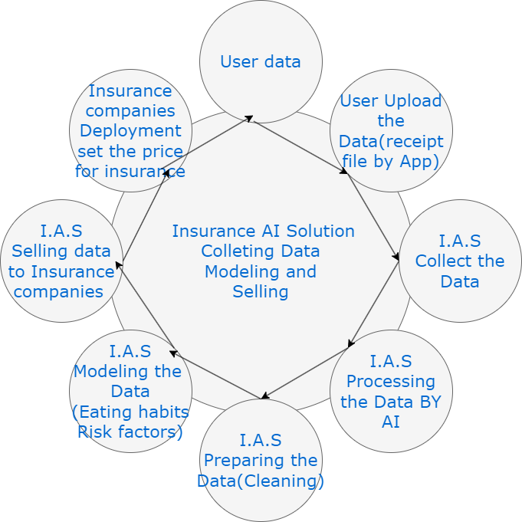

e faz a apresentação do powerpoint mas eu te ajudo:

2) Presentation

Upon completion of your analysis, you are to create a short 5-slide presentation which will provides a summary of:

i) your project concept,

ii) the business analysis method you used, and

iii) what you have concluded from using the method, or methods.

<https://www.kaggle.com/code/gauravsahani/starter-food-demand-predictions> olha esse link

References

<https://www.precedenceresearch.com/generative-ai-in-insurance-market#:~:text=Generative%20AI%20helps%20the%20process,transform%20the%20insurance%20business%20model>. (27/02)